**1.INTRODUCTION:**

Carbon dioxide (CO2) is released into Earth’s atmosphere mostly by the burning of carbon-containing fuels and the decay of wood and other plant matter. Under all conditions found naturally on Earth, CO2 is an invisible, odorless gas. It is removed from the atmosphere mostly by plants, which extract carbon from CO2 to build their tissues, and by the oceans, in which CO2 dissolves.

 In the deep geological past, atmospheric CO2 has sometimes been much higher than today; for example, about 500 million years ago there was over 15 times as much atmospheric CO2 as there is now. On the other hand, until human beings began to burn large amounts of fossil fuel in the late eighteenth century, CO2 had been stable for about 20 million years. Due to anthropogenic (human-caused) emissions, atmospheric CO2 is now significantly higher than at any time in the last 800,000 years and probably in the last 20 million. This change has happened in a mere 200 years, which is instantaneous by geological standards.

* 1. **OVERVIEW:**

The dataset contains its exhaustive demonstration of Co2 emission in world wide across the countries. It includes its data from 1975 to till now that is 2020. Here we are going to analyse Co2 emission in state wise, Region wise, and overall contribution in India.

* 1. **PURPOSE :**

 Carbon dioxide (CO2) emissions dataset is one of our most-used datasets on Our World in Data. It is the key metric we need to understand our progress on slowing global climate change.

The Global Carbon Project updates its dataset annually with data on global and national CO2 emissions, extending back to the year 1750.

We present our data for three key metrics:

* ‘Fossil CO2 emissions’, which includes all emissions from energy production (from coal, oil, gas and flaring) plus direct industrial emissions from cement and steel production. It *does not* include emissions from land use change.
* Land use change emissions.
* The combined total of land use change and fossil CO2 emissions.

**2.PROBLEM DEFINITION AND DESIGN THINKING:**

**2.1 EMPATHY MAP:**

An empathy map is a collaborative visualization used to articulate what we know about to particular type of user. It externalizes knowledge about users in order to 1) Create a shared understanding of user needs 2) Aid in decision making.

**2.2 BRAINSTROM MAP:**

A mind map is a visualization technique and brainstorm tool which allows you to explore a central idea, and all of its related topics, in a non-linear way. When brainstorming, or attempting to see a particular topic from all angles, linear tools—like lists—aren’t always the best solution.

**3.RESULT:**

The output we gained on the topic of UNEARTHING THE ENVIRONMENTAL IMPACT OF HUMAN ACVTIVITY: A GLOBAL CO2 EMISSION ANALYSIS.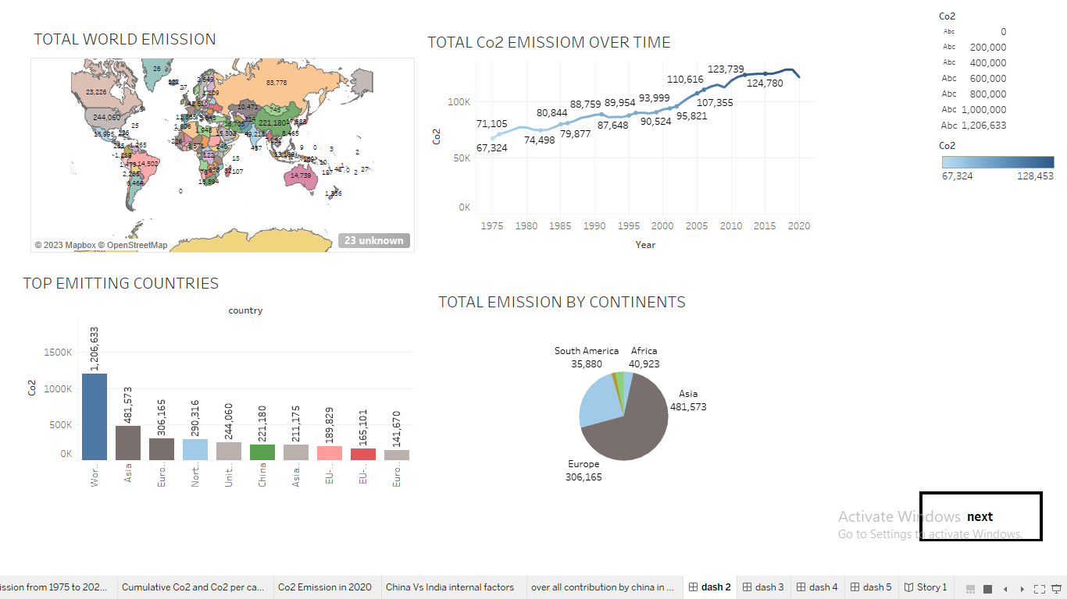

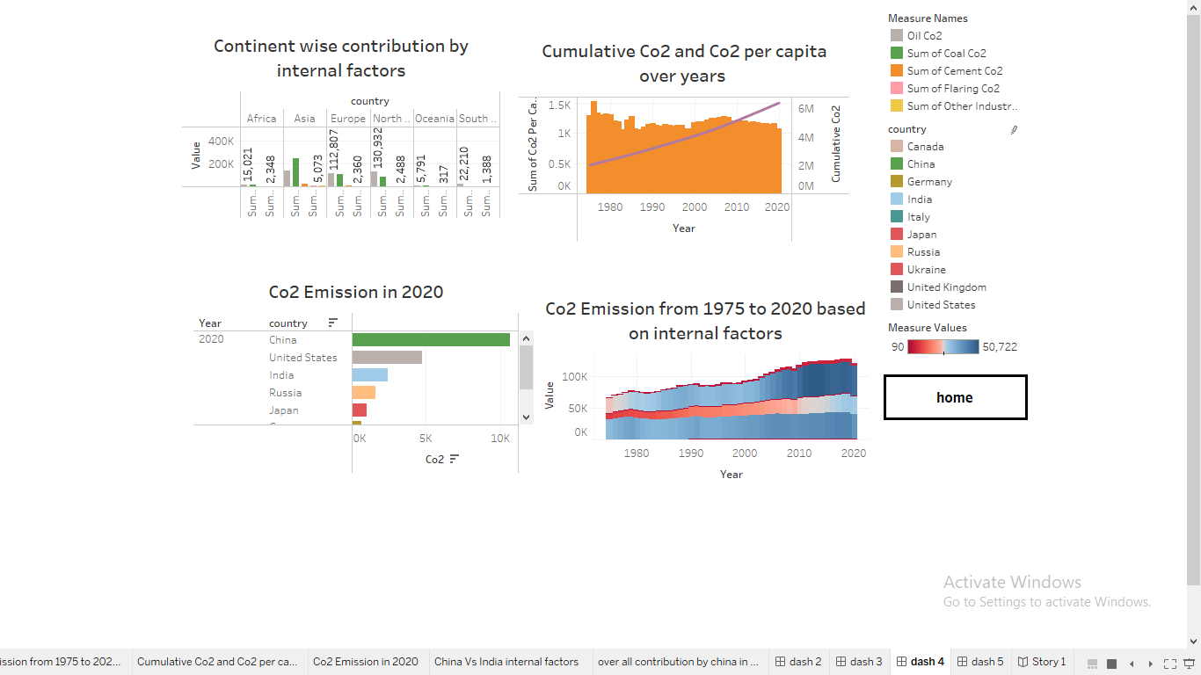

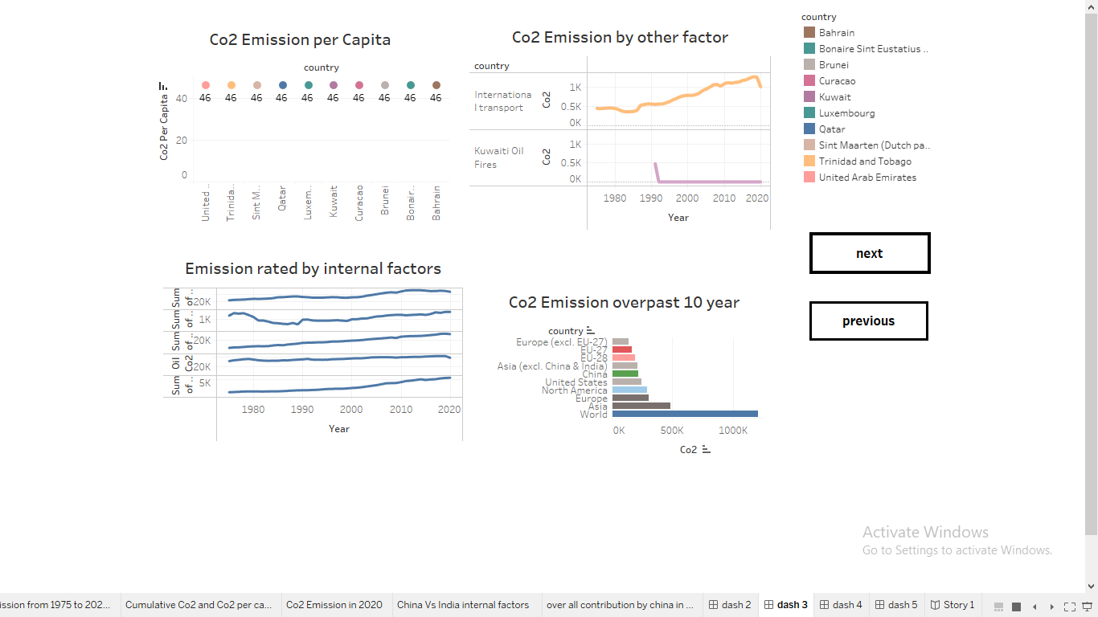

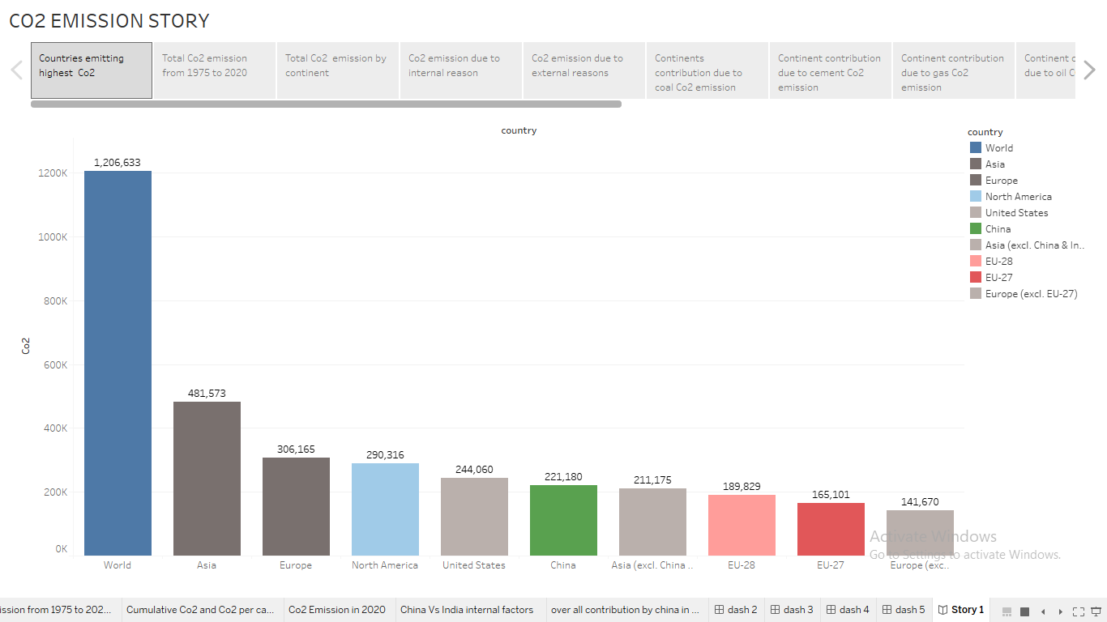

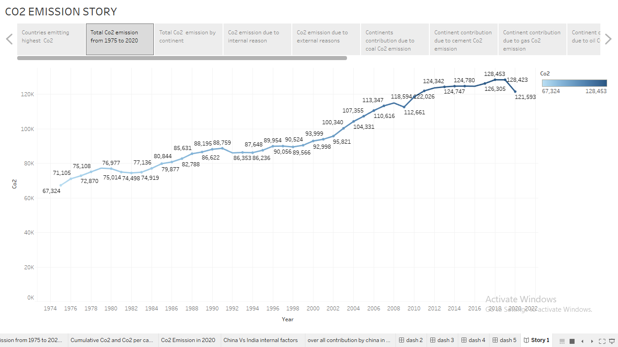

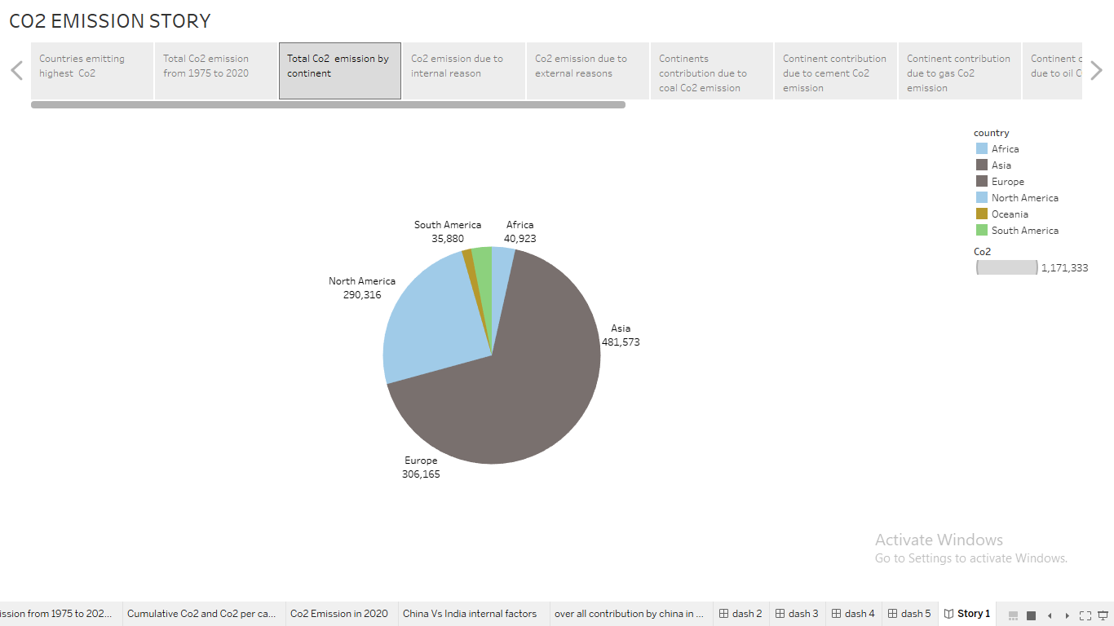

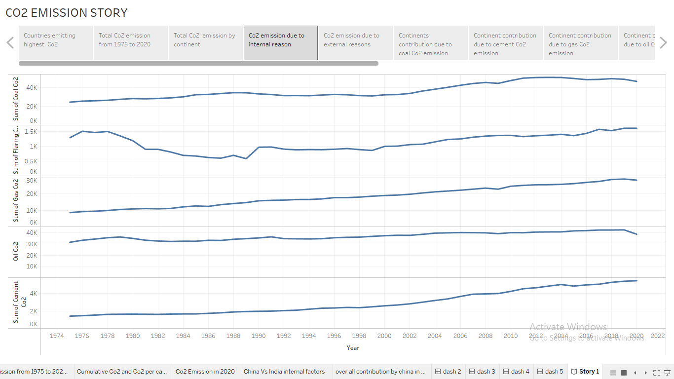

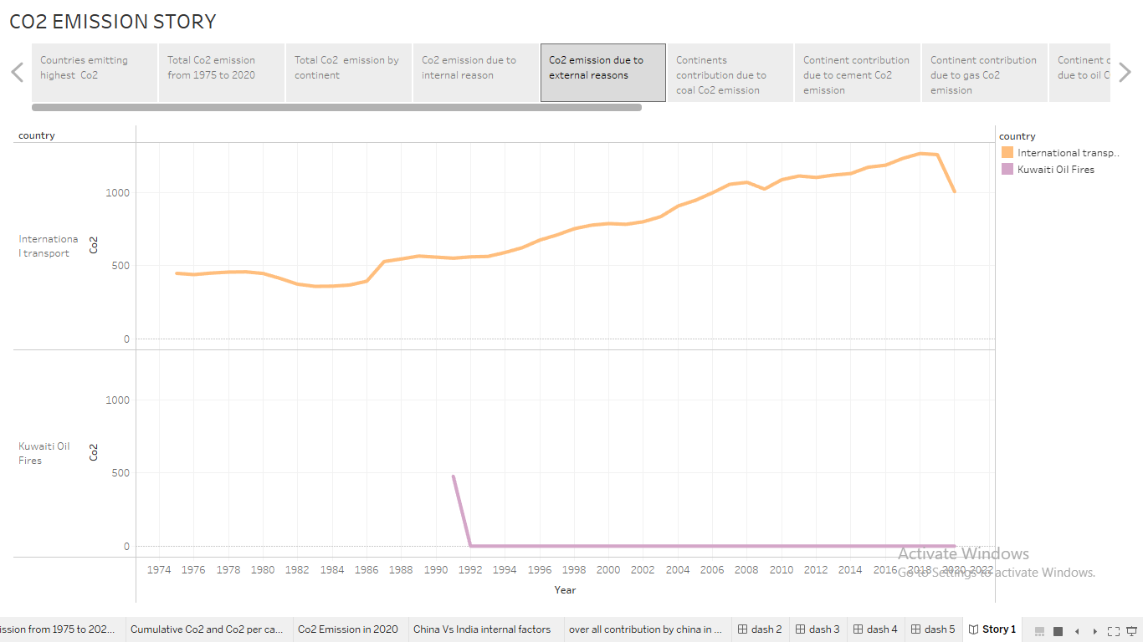

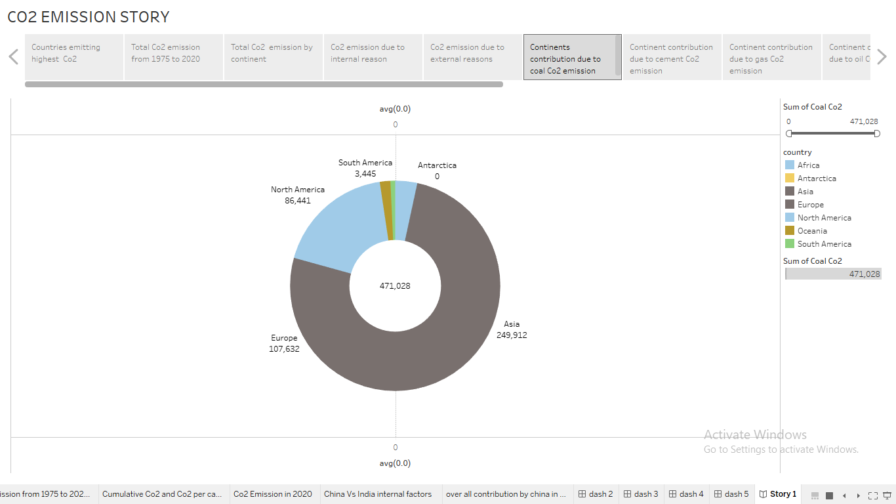

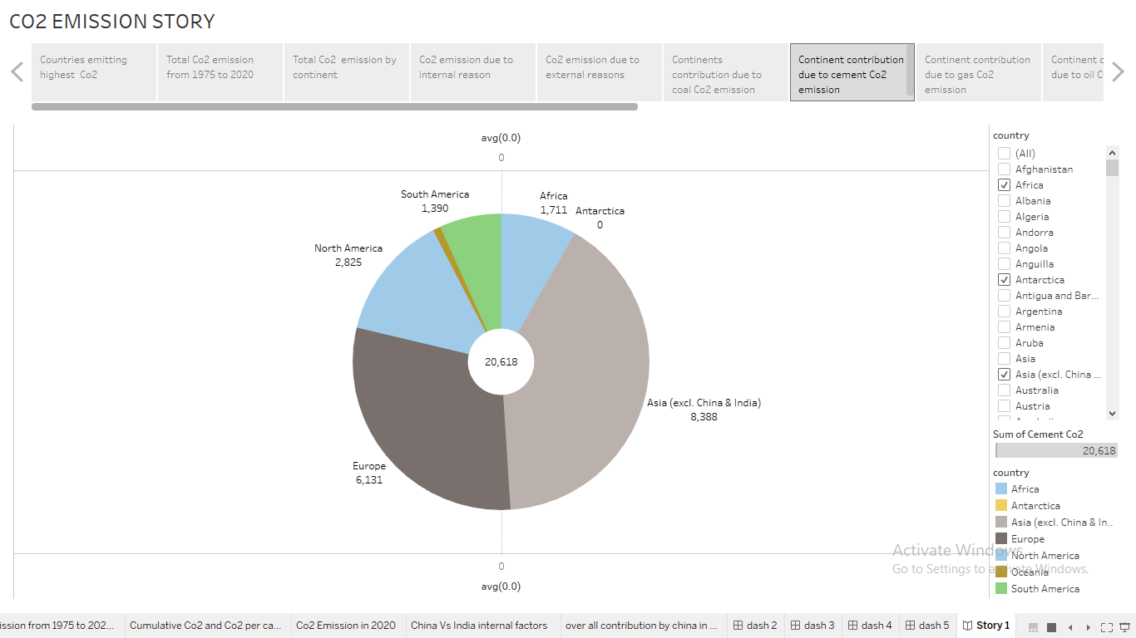

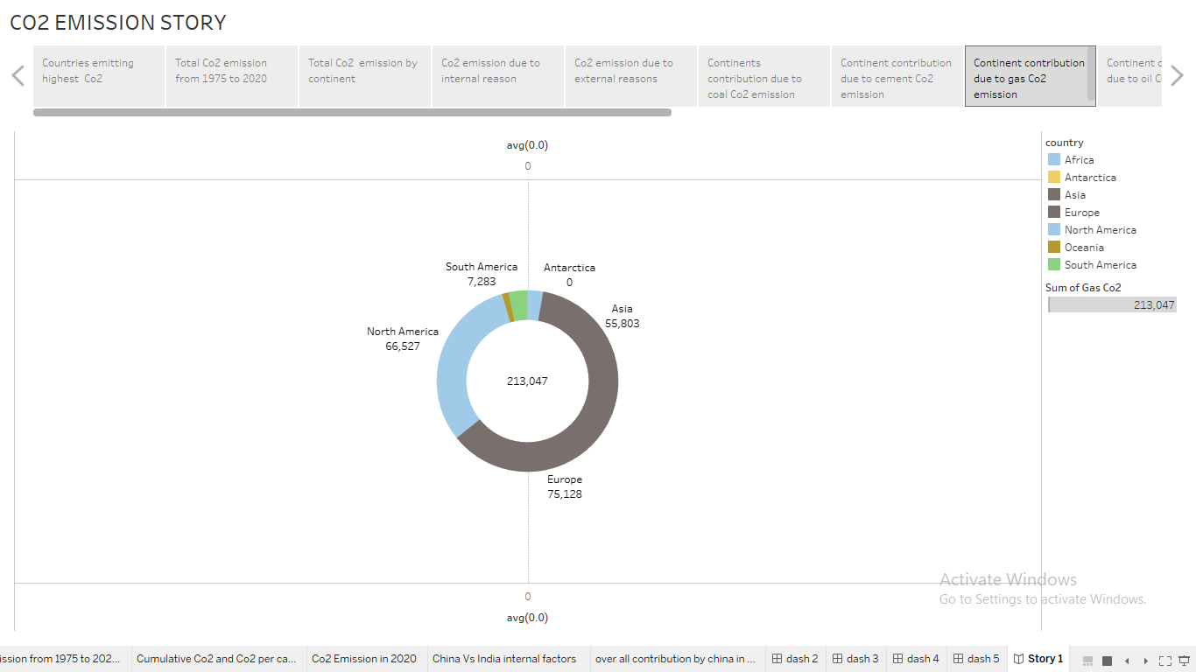

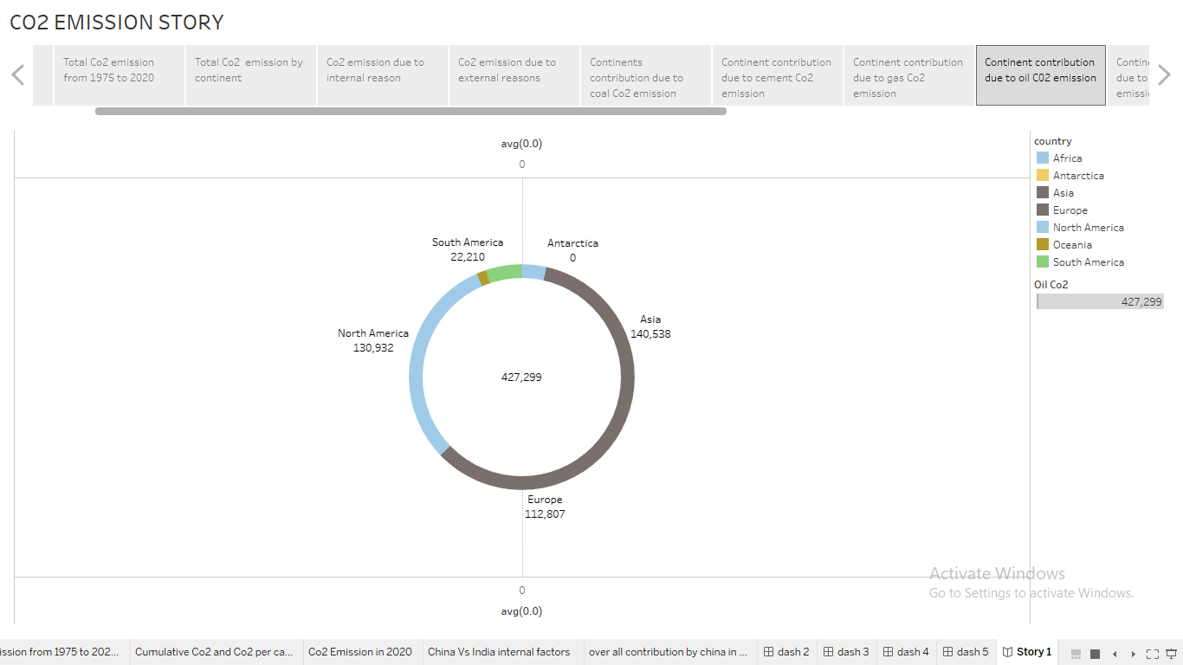

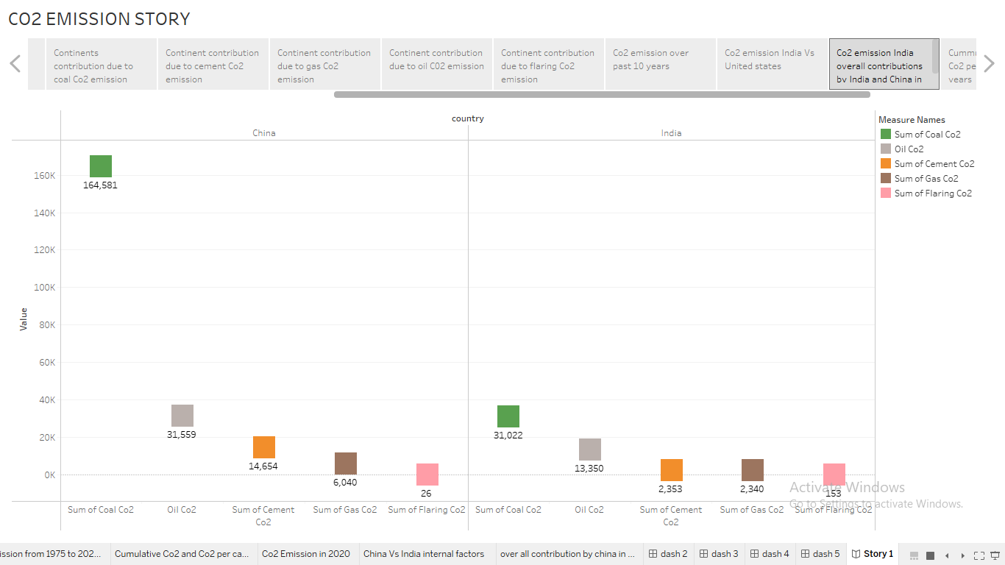

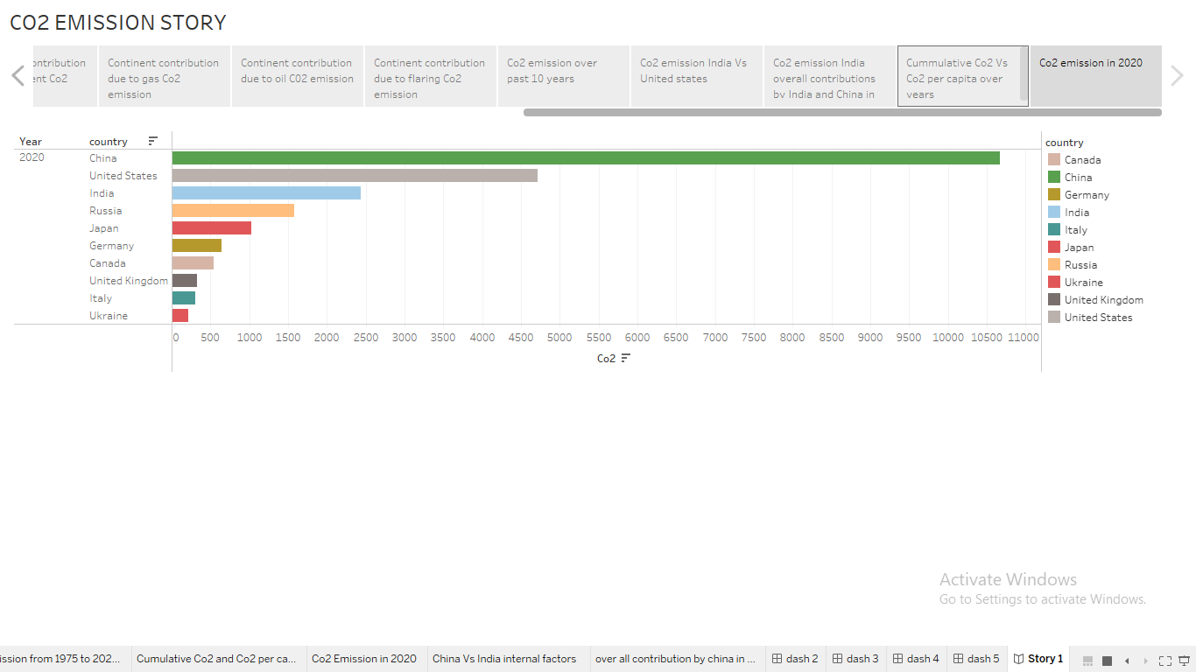

**4.ADVANTAGES OF CO2 EMISSION:**

**Green plants grow faster with more CO2. Many also become more drought- resistant because higher CO2 levels allow plants to use water more efficiently. More abundant vegetation from increased CO2 is already apparent.**

**Carbon dioxide is Earth's most important greenhouse gas: a gas that absorbs and radiates heat. Unlike nitrogen or oxygen, greenhouse gases absorb heat radiating from the Earth's surface and re-release it in all directions—including back toward Earth's surface.**

**Carbon dioxide is used as a refrigerant, in fire extinguishers, for inflating life rafts and life jackets, blasting coal, foaming rubber and plastics, promoting the growth of plants in greenhouses, immobilizing animals before slaughter, and in carbonated beverages.**

**It is essential for the survival of most living organisms and cycles in the ecosystem, through respiration (aerobic and anaerobic), photosynthesis, and combustion.**

**DISADVANTAGES OF CO2 EMISSION:**

High carbon dioxide levels can cause poor air quality and can even extinguish pilot lights on gas-powered appliances.

Carbon dioxide in the atmosphere warms the planet, causing climate change. Human activities have raised the atmosphere's carbon dioxide content by 50% in less than 200 years.

It  causes global warming, which causes climate change, symptoms of which include melting of the polar ice caps, the rising of sea levels, the disturbance of animals' natural habitats, extreme weather events, and so many more negative side effects that are dangerous .

Carbon dioxide (CO2) is a greenhouse gas. This means that it causes an effect like the glass in a greenhouse, trapping heat and warming up the inside. This effect is important: without the CO2 that naturally exists in the atmosphere, Earth might be too cold to support human life.

**IMPORTANCE OF CO2 EMISSION IN DAILY LIFE:**

 It's a greenhouse gas. That means CO2 in the atmosphere traps heat close to Earth. It helps our planet hold onto some of the heat it gets from the Sun so the energy doesn't all escape back into space.

If it weren't for this greenhouse effect, Earth's ocean would be frozen solid. If not for the greenhouse effect, Earth would be an ice ball! Earth would not be the beautiful blue and green planet of life that it is.

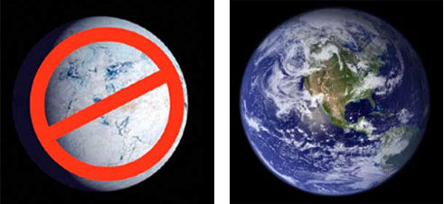

So, CO2 and other greenhouse gases are good — but only up to a point. CO2 is so good at holding in heat from the Sun that even a small increase in CO2 in the atmosphere can make Earth even warmer.

All living things on Earth contain carbon. Even you contain carbon. Lots of it! Like every other living thing on this planet, we are a part of Earth's carbon cycle. Plants take in CO2. They keep the carbon and give away the oxygen. Animals breathe in the oxygen and breathe out carbon dioxide. Carbon, including carbon dioxide, has cycled into and out of the air for a long time. This cycling of carbon has stayed balanced over long periods of time.

**5.APPLICATION OF CO2 EMISSION:**

**Carbon dioxide**, (CO2), a colourless [gas](https://www.britannica.com/science/gas-state-of-matter) having a faint sharp [odour](https://www.britannica.com/science/odor) and a sour taste. It is one of the most important [greenhouse gases](https://www.britannica.com/science/greenhouse-gas) linked to [global warming](https://www.britannica.com/science/global-warming), but it is a minor component of [Earth’s](https://www.britannica.com/place/Earth) [atmosphere](https://www.britannica.com/science/atmosphere) (about 3 volumes in 10,000), formed in [combustion](https://www.britannica.com/science/combustion) of [carbon](https://www.britannica.com/science/carbon-chemical-element)-containing materials, in [fermentation](https://www.britannica.com/science/fermentation), and in respiration of [animals](https://www.britannica.com/animal/animal) and employed by [plants](https://www.britannica.com/plant/plant) in the [photosynthesis](https://www.britannica.com/science/photosynthesis) of [carbohydrates](https://www.britannica.com/science/carbohydrate). The presence of the gas in the atmosphere keeps some of the [radiant energy](https://www.britannica.com/science/radiant-energy) received by Earth from being returned to space, thus producing the so-called [greenhouse effect](https://www.britannica.com/science/greenhouse-effect). Industrially, it is recovered for numerous [diverse](https://www.merriam-webster.com/dictionary/diverse) applications from flue gases, as a by-product of the preparation of [hydrogen](https://www.britannica.com/science/hydrogen) for synthesis of [ammonia](https://www.britannica.com/science/ammonia), from limekilns, and from other sources.

Carbon dioxide was recognized as a gas different from others early in the 17th century by a Belgian chemist, [Jan Baptista van Helmont](https://www.britannica.com/biography/Jan-Baptista-van-Helmont), who observed it as a product of both fermentation and combustion. It liquefies upon compression to 75 kg per square centimetre (1,071 pounds per square inch) at 31 °C (87.4 °F) or to 16–24 kg per sq cm (230–345 lb per sq in.) at −23 to −12 °C (−10 to 10 °F). By the mid-20th century, most carbon dioxide was sold as the liquid. If the liquid is allowed to expand to [atmospheric pressure](https://www.britannica.com/science/atmospheric-pressure), it cools and partially freezes to a snowlike solid called [dry ice](https://www.britannica.com/technology/dry-ice) that [sublimes](https://www.britannica.com/science/sublimation-phase-change) (passes directly into vapour without melting) at −78.5 °C (−109.3 °F) at the [pressure](https://www.britannica.com/science/pressure) of the normal atmosphere.

**6.CONCLUSION:**

This study gives a detailed view of co2 emission by several countries across the world, It aims to provide a holistics as well as comparative investigation based on socio-economic and technological characteristics. From this paper we can understand the co2 emission from 1975 to 2020. We plot many graphs from region wise,state wise, countries wise using tableau.

**7.FUTURE SCOPE:**

This diagram shows the main sources of our scope 1,2 and 3 emissions.

